**Customer Journey Map**

# Scenario:

A nature enthusiast or researcher uses the Enchanted Wings web app to identify butterfly species from captured images.

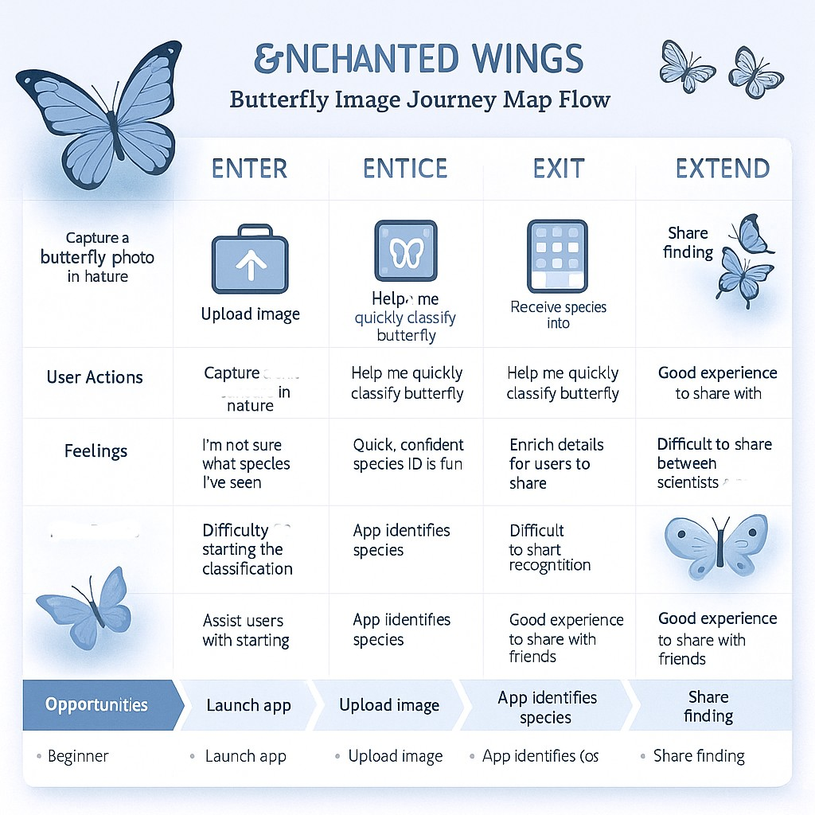

# Customer Journey Steps:

## 1. Discover the App

User hears about Enchanted Wings through educational events, social media, or peer recommendation.

## 2. Open the Web App

User opens the app via browser and lands on the home page.

## 3. Upload an Image

User selects or drags an image of a butterfly from their device and uploads it.

## 4. Model Processes the Image

Backend receives the image, preprocesses it, and passes it through the VGG16 model.

## 5. View Prediction Result

App displays the predicted butterfly species name and shows the uploaded image with it.

## 6. Learn More

User is optionally directed to species info, habitat, and conservation facts.

## 7. Repeat or Share

User uploads more images or shares their identification results.

# Positive Moments

- Easy upload and clear results interface  
- Fast predictions using transfer learning  
- Educational info builds knowledge and engagement

# Negative Moments

- Confusion if prediction is wrong  
- Lack of feedback or tip for blurry images  
- Limited offline accessibility

# Opportunities for Improvement

- Add feedback mechanism for misclassified images  
- Allow offline use or Android app version  
- Include species confidence score and alternatives